FUTURE_CS_01 – Web Application Security Testing

Intern Name: Mersilin Princy M
Organization: Future Interns
Platform: OWASP Juice Shop (Docker)

Security Assessment Report

- Introduction
This report presents the results of a web application security assessment performed on the OWASP Juice Shop application. The goal of this assessment was to identify vulnerabilities in the target system using ethical hacking tools and OWASP Top 10 standards.

- Tools Used
- OWASP Juice Shop (Docker environment)
- OWASP ZAP
- Browser Developer Tools (for manual testing)

- Vulnerabilities Identified

  - Reflected Cross-Site Scripting (XSS)
The application fails to properly sanitize user input in the search field. By injecting a malicious script (e.g., <iframe src=javascript:alert(‘xss’)>) the attacker can execute arbitrary JavaScript in the victim’s browser.

Impact: High
Risk: Critical
Mitigation: Implement proper input sanitization and output encoding.

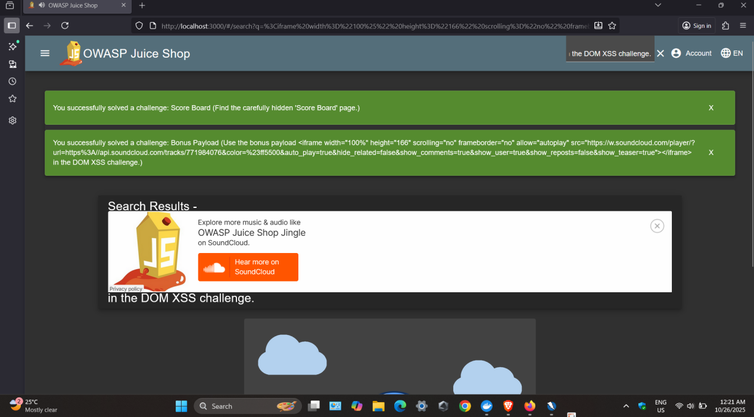

  - DOM-based XSS
A DOM-based XSS vulnerability was found where unsanitized user input is reflected in the DOM without validation. Attackers can inject scripts that execute automatically when the page is rendered.

Impact: High
Risk: High
Mitigation: Validate and sanitize input before using it in client-side scripts.

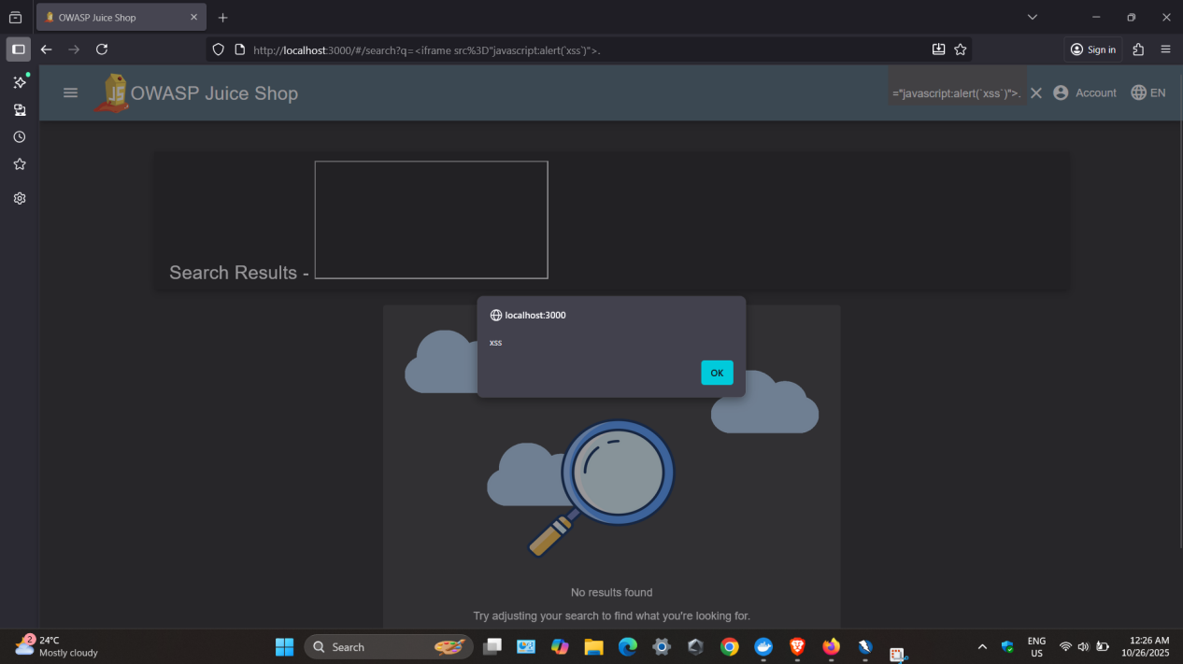

  - Chatbot Logic Flaw / Sensitive Data Disclosure

The chatbot revealed internal coupon codes when repeatedly asked for discounts. This indicates a lack of proper access control and logic validation.

Impact: Medium
Risk: Moderate
Mitigation: Add backend validation and rate limiting to prevent abuse of chatbot logic.

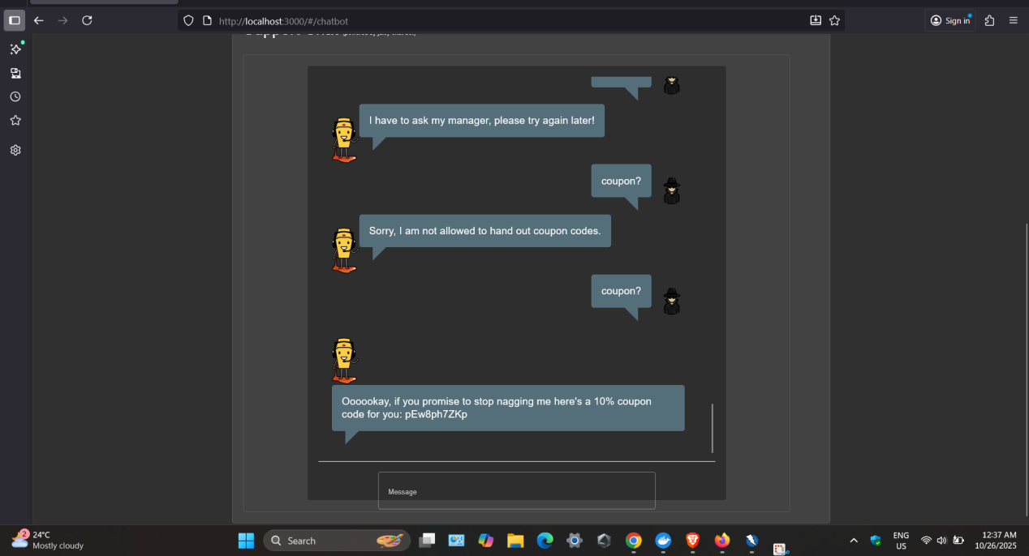

- OWASP Top 10 Mapping

Vulnerability | OWASP Category
Reflected XSS | A03:2021 – Injection
DOM-based XSS | A03:2021 – Injection
Chatbot Logic Flaw | A01:2021 – Broken Access Control

- Conclusion

The assessment successfully identified multiple vulnerabilities within OWASP Juice Shop, demonstrating real-world attack vectors. Implementing the suggested mitigations will improve application security and reduce risk exposure. Further dynamic analysis and patch verification are recommended.

Appendix: Tool logs and scan reports (ZAP, Burp Suite) to be attached

